Asynchronous Microservice in AWS

Publisher/Subscriber Communication Model

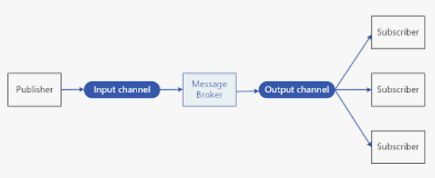

RabbitMQ = message broker service

1. Create instance on EC2, T2 Ubuntu.
   1. Get public IP address
   2. Edit inbound security rules
      1. All traffic, V4
      2. All traffic, V6
2. Create & run 3 PuTTY terminals, one for each, using the public IP address above:
   1. RabbitMQ
      1. The below commands:
         1. Get compute update
         2. Install docker
         3. Pull RabbitMQ Docker image & build
         4. Install Go & streadway
         5. Run prod.go

cd rabbitMQ/

sudo apt update

sudo snap install docker

sudo docker pull rabbitmq

sudo docker run -it --rm --name rabbitmq -p 5672:5672 -p 15672:15672 rabbitmq:3.11-management

// run rabbitmq server!

// http://<dns>:15672

* + 1. Get the DNS from the instance, copy it into a web browser, then paste “:<port #>” after it
    2. Log on to RabbitMQ UI website
       1. Username: guest
       2. Password: guest
    3. Now you’re on the RabbitMQ UI to manage the message broker
  1. Publisher (AKA producer)
     1. Setting this up, we will be able to write messages to our subscriber
     2. Take the 2nd PuTTY instance &:
        1. Also clone the repo: <https://github.com/palomasoftware/MSDS434_ModuleEight_GolangRabbitMQ.git>
        2. Go into rabbitMQ_producer.go to change the DNS to our instance:
           1. 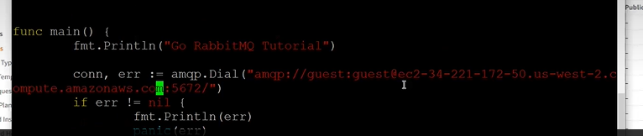

sudo apt install golang-go

vi RabbitMQ_producer.go

Change the port to 5672 & the DNS

go install github.com/streadway/amqp@latest

go mod init github.com/TutorialEdite/go-rabbitmq-tutorial

go mod tidy

go run prod.go

* + 1. You should be able to at this point see messages written in PuTTY AND if you go into RabbitMQ UI, a spike in activity
       1. 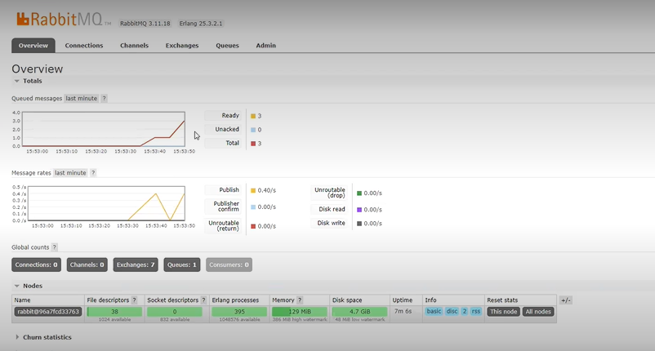
  1. Subscriber (AKA consumer)
     1. Take the 3rd PuTTY instance and:
        1. Clone the repo: <https://github.com/palomasoftware/MSDS434_ModuleEight_GolangRabbitMQ.git>
        2. Go into rabbitConsumer.go to change the DNS to our instance:
           1. 

sudo apt install golang-go

vi prod.go

go install github.com/streadway/amqp@latest

go mod init github.com/TutorialEdite/go-rabbitmq-tutorial

go mod tidy

go run prod.go

* + 1. After running, you should be able to see the Hello World messages